**CS 3840 Computer Networking**

**Homework 5**

Please refer to the syllabus for expectations of homework professionalism and appearance. Your homework is expected to be an individual effort. It is also expected to be neat and clearly organized. The University provides access to many software applications. Use them. Handwritten papers and poorly drawn diagrams are not acceptable. You must submit your answers of the problems in one Word or PDF file by the specified due date and time. You can find the link for your softcopy submission in Blackboard.

***Total points: 16 points***

The cover page of your homework will contain only the following information in the format given below:

**Name: Andrew Koenig**

**700#: 700690760**

**Course #: CS 3840**

**Homework #: Homework 5**

1. [8 pts] Consider the network shown below. Suppose AS1 and AS2 are running OSPF for their intra-AS routing protocol. Suppose AS3 and AS4 are running IGRP for their intra-AS routing protocol. Suppose eBGP and iBGP are used for the inter-AS routing protocol.
   1. (1 pt) Router 4c learns about prefix x from which routing protocol: OSPF, IGRP, eBGP, or iBGP? OSPF
   2. (1 pt) Router 3a learns about x from which routing protocol? IBGP
   3. (1 pt) Router 1c learns about x from which routing protocol? EBGP
   4. (1 pt) Router 1d learns about x from which routing protocol? IBGP

Once router 1d learns about x, it will put an entry (x, I) in its forwarding table.

* 1. (2 pt) Will I be equal to I1 or I2 for this entry? Explain why in one sentence. I1 because it’s the shortest path that it learned it from.
  2. (2 pt) Now suppose there is another AS, called AS5, which lies on the path between AS2 and AS4 (not shown in diagram). Suppose router 1d learns that x is accessible via AS2 AS5 AS4 as well as via AS3 AS4. Will I be set to I1 or I2? Explain why in one sentence. I1 because it is a shorter path.

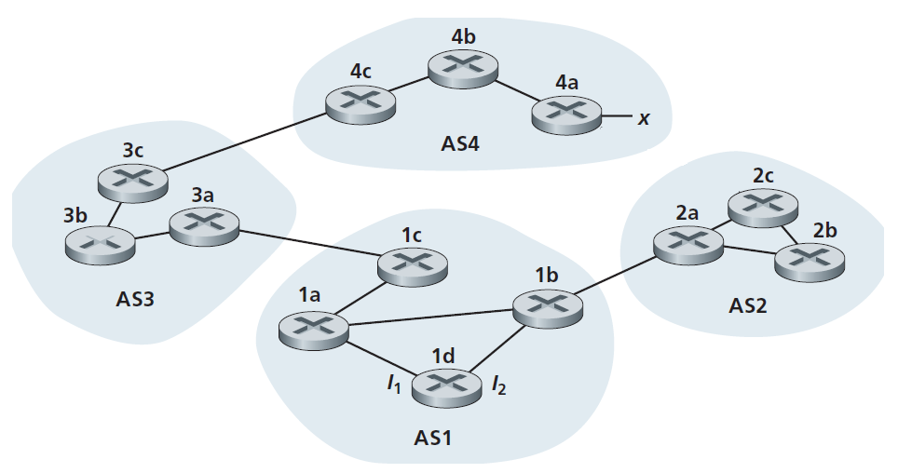

1. [4 pts, Chapter 6] The below figure describes sending a datagram via a router. In this scenario, Host A sends a datagram to Host B through the router R. What would be the source/destination MAC addresses and source/destination IP addresses in Host A? Explain the rationale for your answers.

MAC SRC: 74-29-9C-E8-FF-55

MAC DST: 1A-23-F9-CD-06-9B

IP SRC: 111.111.111.111

IP DST: 222.222.222.221

The MAC source will be the device that is sending the packet, the MAC destination will be the routers MAC because A has to send its packet to the router to be routed using layer 2. The IP source will be of device A and the IP destination will be host B’s address so the router knows where to send the packet in layer 3.

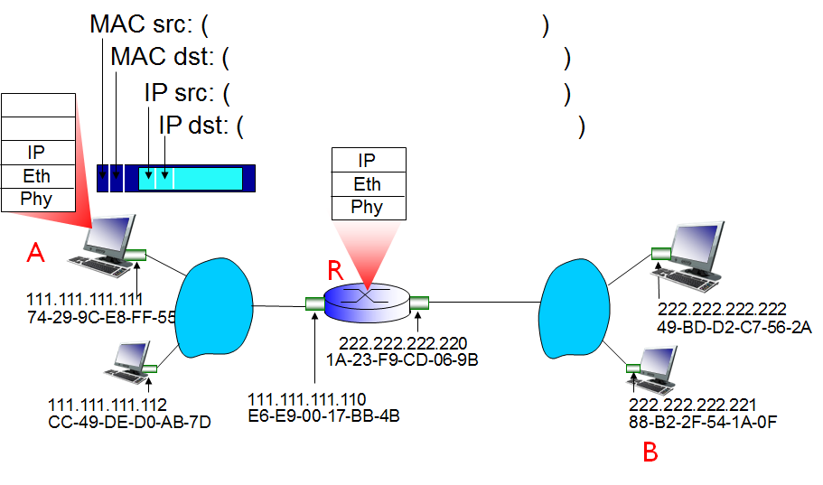

1. [4 pts] Suppose host A sends a frame to host E, and host E responds to host A. Complete the switch tables S2 and S4?

|  |  |
| --- | --- |
| MAC address | Interface |
| MAC A | 1 |
|  |  |



S2 S4

|  |  |
| --- | --- |
| MAC address | Interface |
| MAC A | 4 |
| MAC E | 2 |